**Section 1–5B: Solving Compound Inequalities**

You can join two inequalities with the word ***and*** or the word ***or*** to form a **compound inequality**. To solve a compound inequality containing ***and***, find all values of the variable that make both inequalities true.

**Example 1: Solving an “AND” Inequality**

What is the solution of $7<2x+1$ and $3x≤18$? Graph the solution.

You must solve each inequality separately:

**How do you graph a compound inequality with “and”?**

You must find the intersection of the solutions of the two inequalities.

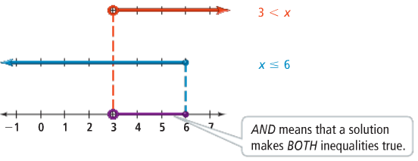

You can collapse a compound ***and*** inequality, like $5<x+1$ and $x+1<13$, into a simpler form, $5<x+1<13$. You read $5<x+1<13$ as “ $x+1$ is greater than $5$ and less than $13$.”

To solve a compound inequality containing ***or***, find all values of the variable that make at least one of the inequalities true.

**Example 2: Solving an “OR” Inequality**

What is the solution of $7+k≥6$ or $8+k<3$? Graph the solution.

You must solve each inequality separately:

**How do you graph a compound inequality with “or”?**

You must graph all of the solutions of each inequality, not just the solutions of both inequalities.

